This is a BLANK contract for your review only. Along with submission of your deposit, please send the completed Forever Home Questionnaire, Contact Form, and Shipping Information Form to blueskyedobermans@gmail.com. Within 24 hours of receiving your deposit and forms, a completed contract will be emailed to you containing your specific puppy information and signed/dated by Breeder.
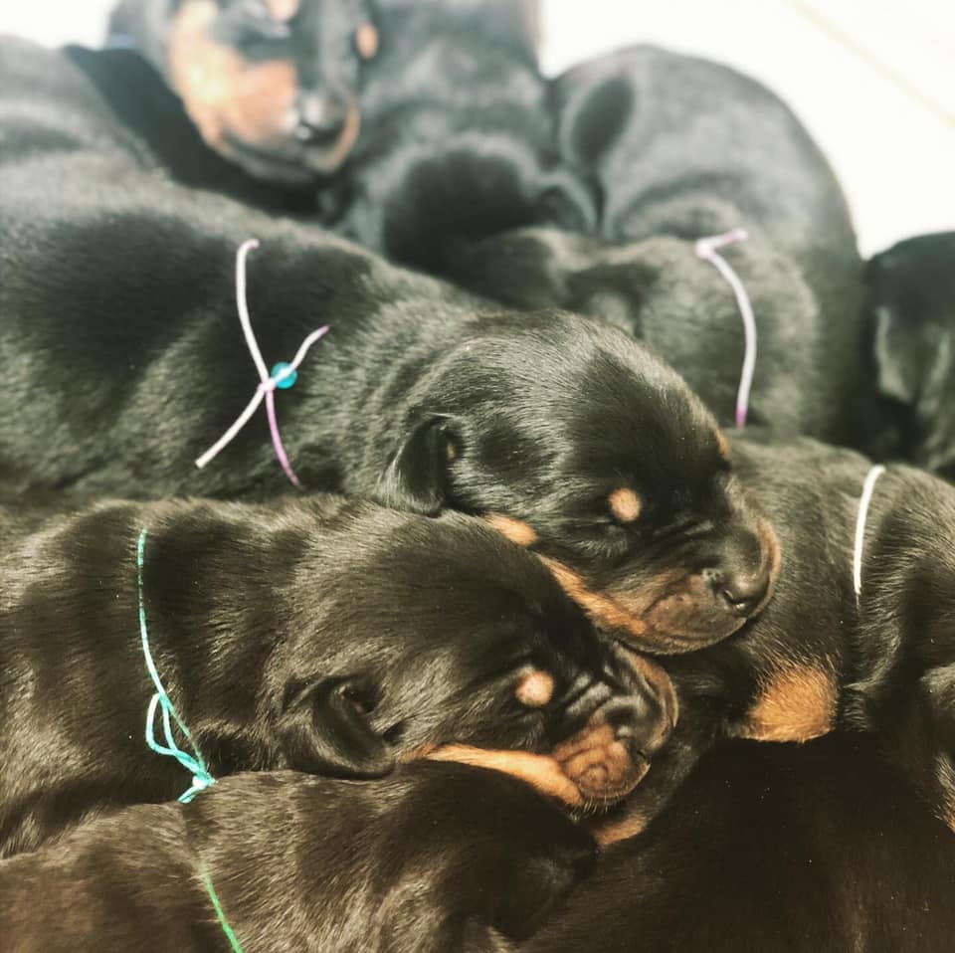
Blue Skye Dobermans Puppy Contract

BLUE SKYE DOBERMANS : PUPPY CONTRACT
This contract is made this day, , 2021, by and between BLUE SKYE DOBERMANS, by Natalie Robino, hereinafter called, “BREEDER” and , hereinafter called “BUYER”;
Buyer Name:
Address:
Home Phone:
Cell Phone:
Email:

PUPPY INFORMATION:
Breed:
Sire:
Dam:
Sex: Collar Color:
Color:
Whelped:
AKC litter #:
Puppy Sale Price: $
Puppy Deposit Price: $ Deposit Paid On:

Breeder’s Acknowledgment of deposit received: Date:
Balance Remaining Due: $ (plus applicable shipping charges, if transport is required)
**ANY REMAINING BALANCE FOR PUPPIES REQUIRING SHIPMENT IS DUE IN FULL AT LEAST 2 WEEKS PRIOR TO SHIPPING ARRANGEMENTS BEING BOOKED.**
DUE DATE FOR BALANCE IF SHIPPING IS REQUIRED:

**ANY REMAINING BALANCE FOR PUPPIES NOT REQUIRING SHIPMENT IS DUE AT THE TIME OF PICKUP. **
ESTIMATED DATE FOR PICK UP OF CROPPED PUPPIES:

Buyer Initial Here: __________
DEPOSIT

There are no refunds on deposits, in whole or part, for any reason, unless said puppy should no longer be available due to unforeseen illness or accident. Buyer will then have the option to be refunded deposit or transfer to a future litter produced by BLUE SKYE DOBERMANS. Buyer has paid a Non-Refundable deposit of $00.00 on , 2021; any outright cancellation made by Buyer will forfeit deposit. The deposit is a good faith promise of Buyer’s intent to purchase said puppy. In the event of outright cancellation by Buyer, all monies received by Breeder will be retained and used in direct relation to support cost and maintenance. Remaining Balance of said Doberman is $00.00 (plus any shipping fees, if applicable). Said puppy is a purebred Doberman Pinscher and has been Pre-Registered with the American Kennel Club (AKC) under Litter Number: . AKC Registration will be transferred to Buyer after Breeder has received payment in full.

Buyer Initial Here: __________

SHIPPING

Should said puppy require shipment, all transport fees and cost shall be added to remaining balance due and shall be paid in full by .
(Initial One)
_______Shipping will be required Shipping will not be required

REGISTRATION

Breeder will provide Buyer with the American Kennel Club (AKC) Registration Packet needed to complete registration of said puppy. Said puppy shall be registered under Limited AKC Registration, as a pet only and shall not be used for breeding purposes of any kind.

Buyer Initial Here: __________

EAR CROP (Initial One)

By default, all puppies will undergo tail dock, dewclaw removal and ear crop surgeries. If per Buyer request, said puppy’s ears are to remain natural, remaining balance due shall be paid in full one week prior to litter’s scheduled surgery and said puppy will be released to Buyer at 8 weeks of age (8 WEEKS: ). All cropped puppies will be released to forever homes between 9-10 weeks of age, after surgery is complete, sutures are removed and ears have minimal to no scabbing.
No puppy will be released from Breeder prior to 8 weeks of age.
This Doberman will have his/her ears cropped between 7-9 weeks of age.

______ This Doberman will NOT have his/her ears cropped, by request of Buyer.

HEALTH GUARANTEE

Breeder guarantees said puppy against fatal viruses for 48 hours. It is Buyer’s responsibility to take said puppy to a licensed veterinarian within 48 hours of receiving said puppy. Proof of vet visit/exam must be emailed to Breeder at BLUESKYEDOBERMANS@GMAIL.COM within the 48 hours. If said puppy is not examined by a licensed veterinarian within 48 hours of being in Buyer’s care, the health guarantee of said puppy is terminated in its entirety. If the health of said puppy is found to be unsatisfactory by a licensed veterinarian, documented in writing, with a copy provided to Breeder, Buyer may return said puppy immediately to Breeder for a replacement puppy.

No guarantees of any type are offered other than the ones stated within this contract.
Said puppy is guaranteed to be in good health upon release. Said puppy is up-to-date on all age appropriate shots and deworming. All health records stating the dates each age appropriate shot and deworming were given, shall be provided to Buyer upon release of said puppy.

If said puppy should develop a severe genetic health disorder prior to twelve months of age that directly results in death or mandatory euthanasia of said puppy, as documented by veterinary records supplied by Buyer to Breeder, Breeder agrees to replace said puppy. Breeder will provide a replacement puppy as soon as availability permits within one year. Replacement puppy is to be of equal value pick and sex, no refundable money will be allowed. Breeder will supply the replacement puppy, free of charge; any shipping charges will be at Buyer’s expense. Before any replacement is provided, proof of the puppy/dog being euthanized is required or Breeder reserves the right to said puppy/dog. If shipment is necessary for replacement puppy, the burden of cost will be Buyer’s responsibility. Buyer agrees to

purchase said puppy with no other guarantees, expressed or implied, including, but not limited to faults listed in FCI or AKC standard.

This guarantee does not cover: Kennel cough, giardia, coccidia, worms or any type of internal or external parasite (as these can be picked up after leaving the breeder), pneumonia, allergies, demodex, mange, parvo-virus, heart murmur grades 1, 2 & 3, patella lunation grades 1, 2 & 3, umbilical hernia, entropion or ectropion, stenotic nares, inverted tails, cancer, tumors, growths, scabies, mite related illness, any other autoimmune disorders viral or bacterial infections, hypoglycemia, thyroid dysfunction and partial or total cryptorchidism. It also does not cover anything as a result of accident or injury. We have administered age appropriate recommended preventative vaccines related to some of the above health issues, most of which are also treatable conditions. The above health issues are common in ALL breeds and often times are a result of poor diet and/or environment. The dam/sire are healthy and have been through DNA screening for genetic disorders directly associated with the Doberman Breed.
Buyer Initial Here: __________

RETURN POLICY

ALL BLUE SKYE DOBERMANS MUST BE RETURNED TO BREEDER IF BUYER CAN NO LONGER KEEP PUPPY/DOG.
Buyer shall notify Breeder immediately if for any reason and at any time, during the life of said puppy, Buyer cannot maintain ownership of the puppy. The above mentioned puppy shall not be sold, transferred, or given to any individual or to any retail or wholesale establishment for the purpose of sale or resale to the public or to any research institution where medical experimentation or other practices take place. If for any reason and at any time, during the life of said puppy, Buyer cannot keep ownership of said puppy, Buyer must notify Breeder to discuss options for returning and rehoming. Buyer agrees to sign the necessary registration (AKC and/or FCI) papers to return said puppy to Breeder as sole owner of the puppy in the event a return/rehome is necessary. In the event said puppy is returned to Breeder, no refund/replacement or transfer otherwise shall occur.

Buyer Initial Here: __________

ENFORCEMENT & AGREEMENT

Buyer agrees to hereby waive and release Breeder from any liability of any nature, for any injury or damage or loss said puppy may suffer or cause, directly or indirectly, to any property or person, including specifically, but without limitation, any injury or damage resulting from the action of said puppy after transfer of rights and ownership has been given.

Buyer and Breeder agree this contract shall be constructed and enforced in accordance with the laws of the State of Louisiana. Both parties specifically agree that there are no other agreements other than those set forth in this document. Each party acknowledges that they have read and understand the terms and conditions within this contract and have entered into and executed this agreement voluntarily. The terms and conditions of this Agreement may be subject to change by Breeder without notice.
Buyer acknowledges their ability to remain in contact with Breeder via calls, text, or email should they have questions or need advice about said puppy. By acquiring a Blue Skye Doberman puppy, Buyer is gaining a relationship with a breeder who truly cares about the welfare of their dogs.

The signatures below indicate agreement and acceptance of all terms and conditions with the placement of said BLUE SKYE DOBERMANS puppy as outlined in the above sections. Buyer agrees that he/she understands this contract fully, and that this contract is under the jurisdiction of the State of Louisiana.

Breeder Signature: _______________________________________ Date: _________________

Buyer Signature: _________________________________________ Date: _________________

